Lagoon Celebrates 130th Birthday

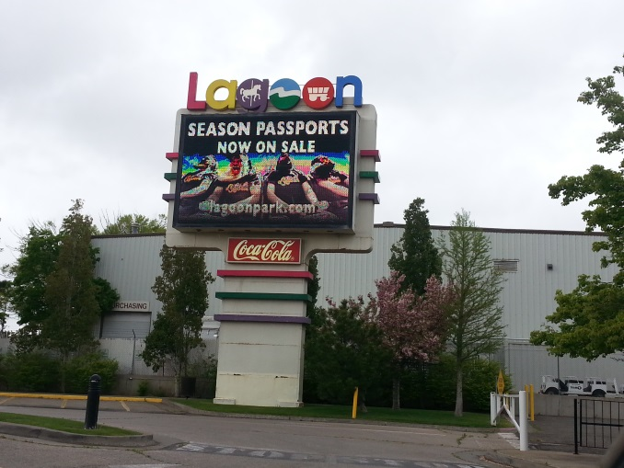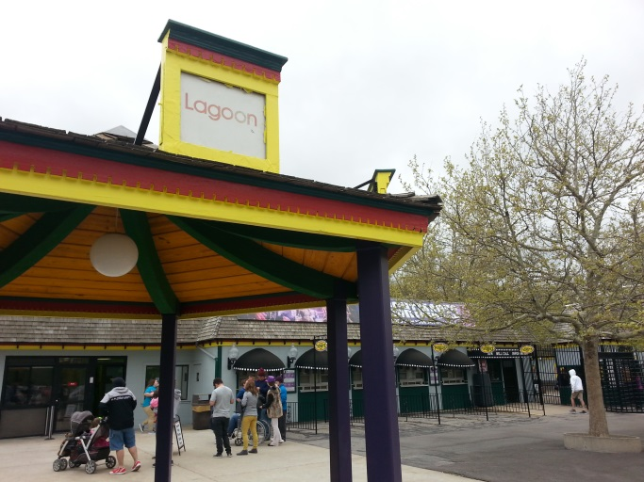

HOST:

This year represents a celebration of both new and old for Utah’s largest amusement park. Lagoon’s newest ride will be the main attraction to the park, as it reflects on its 130th birthday this year. K-Ute reporter, Billy Phifer, has more on the story.

WILLIAM PHIFER, BYLINE: Lagoon is a defining landmark of Farmington’s skyline that is constantly changing over the years with the addition of new rides and rollercoasters. Last year marks the most recent of those changes, when Lagoon opened their newest attraction.

(SOUNDBITE OF ARCHIVED RECORDING)

ADAM LEISHMAN: Yeah, so we welcomed Cannibal last year, which is our newest most expensive ride. It’s a rollercoaster. It’s our tallest ride. It has the most beyond vertical drop in the nation. What’s really special about it also is that Lagoon built it. Its custom made just for Lagoon. Everything is, everything is just for us.

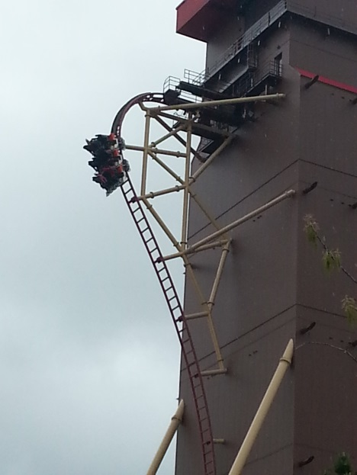PHIFER: That’s Lagoon spokesman, Adam Leishman, who says they worked with a team of international engineers to design the ride. Lagoon opened the brown, red-roofed tower just west of the Farris-Wheel last year, making it the tallest addition to Farmington’s skyline. They are hopeful that the new attraction will bring more people to the park this year.

(SOUNDBITE OF ARCHIVED RECORDING)

LEISHMAN: We opened Cannibal in July of last year and so we’re still riding on that high. It’s still very new to a lot of people. It’s still really special and we’re continuing to celebrate that.

PHIFER: This year brings the perfect opportunity for those who didn’t get to ride the new rollercoaster last year. Sarah is one of those people, as she is visiting the park for the first time this year with her daughter.

(SOUNDBITE OF ARCHIVED RECORDING)

SARAH: My first time today, but that was our third time on it. It’s probably my favorite ride here. It’s really good. My adrenalin is going, I’m like shaking.

PHIFER: She’s not the only one who loves the thrills that the new rollercoaster brings. Three teenagers coming off the ride were also excited about the possibility of riding it multiple times during the summer.

(SOUNDBITE OF ARCHIVED RECORDING)

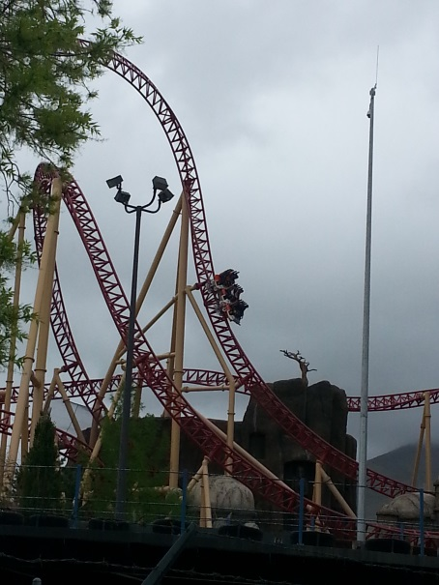TEENAGERS: It was awesome!( It was amazing!) It was dope! We like the part where it kind of, when you go down, it kind of dips in and you kind of feel like you’re getting jerked out of your seat a little bit, it’s just pretty [fun]… and the one where it kind of goes upside down for a little bit. You feel like you’re going to lose your phone.

PHIFER: The ride features a number of twists, turns, and inverted sections of track that were carefully designed to ensure the safety of its passengers.

(SOUNDBITE OF ARCHIVED RECORDING)

LEISHMAN: Another nice thing about the ride itself is about 75 percent of the ride was built here, in Utah, using local vendors.

PHIFER: While the passenger cars were built and designed in Europe, the track was built locally giving Lagoon more options during the construction phase of the project.

(SOUNDBITE OF ARCHIVED RECORDING)

LEISHMAN: Because we didn’t have to ship the track overseas in containers, we were able to build longer lengths of track which makes for fewer joints, fewer fasteners, and in the end is a much smoother rollercoaster.

PHIFER: Although the new rollercoaster will be the main attraction for the park this year, it won’t be the only reason people come to Lagoon. Along with other rides and attractions, the park also has a historical significance as it celebrates its birthday, 130 years after it was founded.

(SOUNDBITE OF ARCHIVED RECORDING)

LEISHMAN: The park actually started in 1886, on the shores of the Great Salt Lake about two, two and a half miles west of here.

PHIFER: According to Leishman, the lake dried up about 10 years later and railroad owner, Simon Bamberger, bought the park and moved it to its current location. Under his ownership, the park served as a railroad destination halfway between Ogden and Salt Lake City. Years later, the park closed down during World War 2, so the Bamberger family leased it to Robert Freed.

(SOUNDBITE OF ARCHIVED RECORDING)

LEISHMAN: In 1953, there was a big fire here. Most of the park burned down. They were able to save the carousel. The front half of the rollercoaster burnt down, but they were able to rebuild it and it’s still here. That was built in 1921. But the following year, in 1954, they were able to rebuild the park, reopen it, and that’s kind of the beginning of where we see Lagoon as it is today.

PHIFER: Over time, the Freed family added more rides and attractions to the park, while some of the rides that were built during Simon Bamberger’s ownership still remain standing today.

(SOUNDBITE OF ARCHIVED RECORDING)

LEISHMAN: That’s really cool for us because, you know, we have a lot of historic rides on the park. We have three rides on the national historic registry.

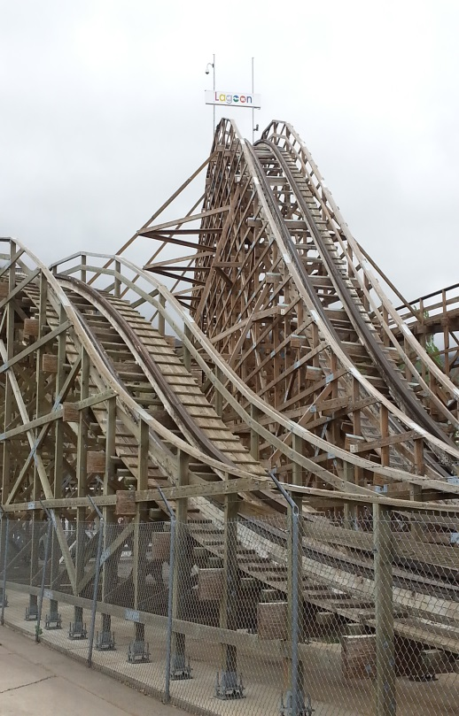PHIFER: Those rides include the hand-carved Herschell-Spillman Carousel that opened in 1906, the Rollercoaster locally known as the White Wooden Rollercoaster, and a ride called Flying Aces. Another ride that serves as a reminder of Lagoon’s history and how the park began is the Wild Kingdom Train, which takes passengers for a ride around the zoo.

(SOUNDBITE OF ARCHIVED RECORDING)

LEISHMAN: That is the only steam powered passenger train operating in Utah today and the only steam powered train operating that goes through a tunnel, in Utah.

PHIFER: Lagoon also features another unique ride called Colossus: The Fire Dragon that opened in 1983. According to Leishman, It is the only double-looping Schwarzkopf rollercoaster operating in the United States. With all of its unique rides and history, Lagoon has been an theme park destination for generations.

(SOUNDBITE OF ARCHIVED RECORDING)

LEISHMAN: And what we see here is we’ll see grandparents bringing their grandchildren to the park, and they’re riding the same rides that they rode themselves as children. So there’s a lot of history here, a lot of heritage, a lot of family stories.

PHIFER: Ogden resident, Anthony Lella, says that he married into one of those families.

(SOUNDBITE OF ARCHIVED RECORDING)

ANTHONY LELLA: My wife went to lagoon as a child all through her teenage years and even as an adult she still loves it. She has fond memories of going with her mother to lagoon, so she enjoys that she gets to take our son.

PHIFER: As Lagoon reflects on both the old and the new this year, it is gearing up for summer hours when it will be the 2nd largest employer in Davis County. Reporting for K-Ute Radio, I’m Billy Phifer.

